Name: __________________________________ Class: ________________

Write am/ is / are
  - She is eleven years old.

  - He __________a teacher.

  - I__________very happy.

  - They ___________ students.

  - We____________ twelve years old.

  - You ___________tall.

  - It ___________a dog.
  - She ________ a farmer.
  - They ___________ good doctors.
  - We _____________wearing uniforms.
10. The children ______________swimming in the pool.

Write the words in the correct order.
1. fifteen / am / I _________________________________________

2. is / American / He _______________________________________

3. Tom / sad / very / is _____________________________________

4. are / students / We _______________________________________

5. They / not / angry / are ____________________________________

6. are / to / the / my / beach / friends / going / go /to/ weekend / this

______________________________________________________

7. salad / now / she / eating / is. _________________________________

Complete the sentences.

0. She / eat / an apple. She’s eating an apple.

1.They / play / soccer. ____________________________________________________

2. He / listen / to music.___________________________________________________

3.We / watch / TV. ______________________________________________________

4. My father / drive / a car. ________________________________________________

5. I / read / a book. ______________________________________________________

Look at the pictures and write.
watch TV
read a book
talk
ride a bike
dance
eat a sandwich
write
sit on a chair
swim


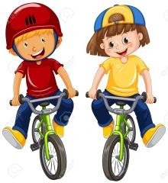

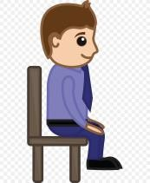


  - He’s eating a sandwich.

1.They ___________________________

2. She ____________________________

3. He ___________________________

4. He ______________________________

IV. Look at the pictures and write.
watch TV
read a book
talk
ride a bike
dance
eat a sandwich
write
sit on a chair
swim

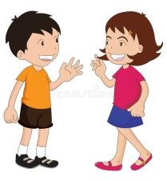

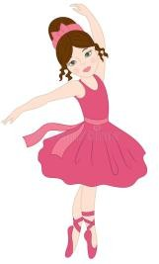
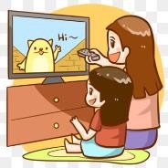

5. They _________________________

6. This boy ______________________

7. Maria ________________________

8. The girls _____________________

  - They’re talking.

  - He’s writing.

  - She’s dancing.

  - They’re watching TV.

